Orientation Package

Algoma Youth Action Alliance (AYAA)

AYAA Mission:

The AYAA is committed
to supporting healthy
communities and creating
change by empowering
young people through
leadership opportunities.

AYAA Values:

HealthSocial Justice
LeadershipTeamwork
DiversityCreativity
★ Respect 

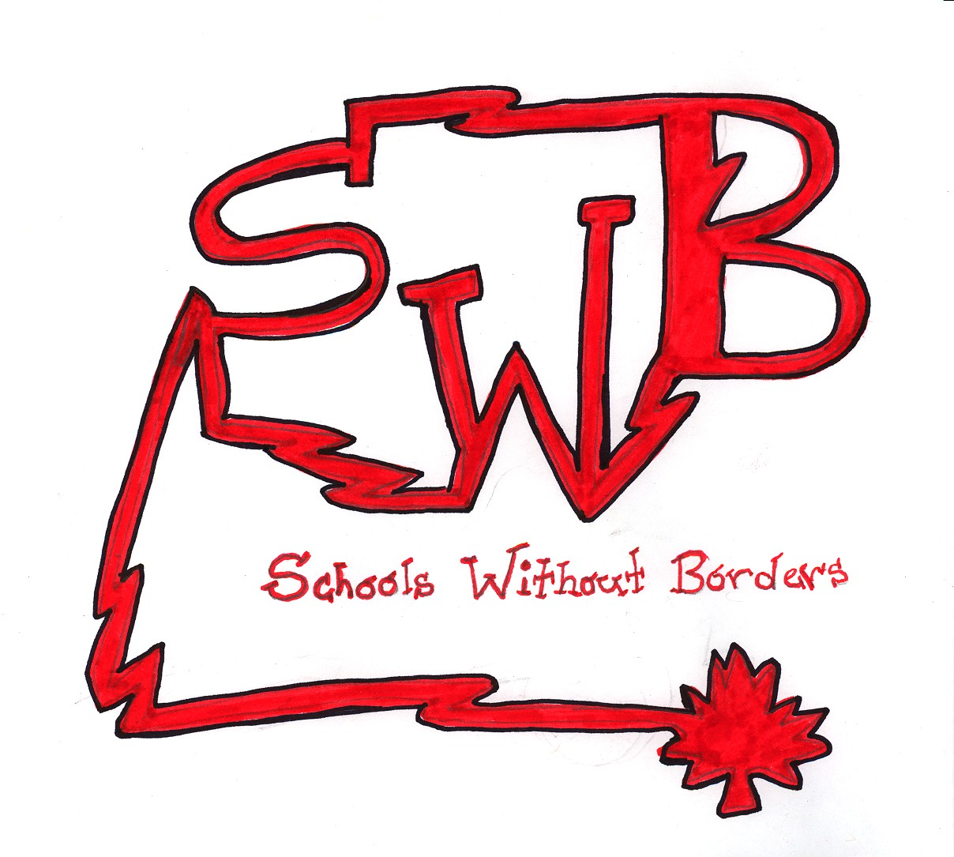
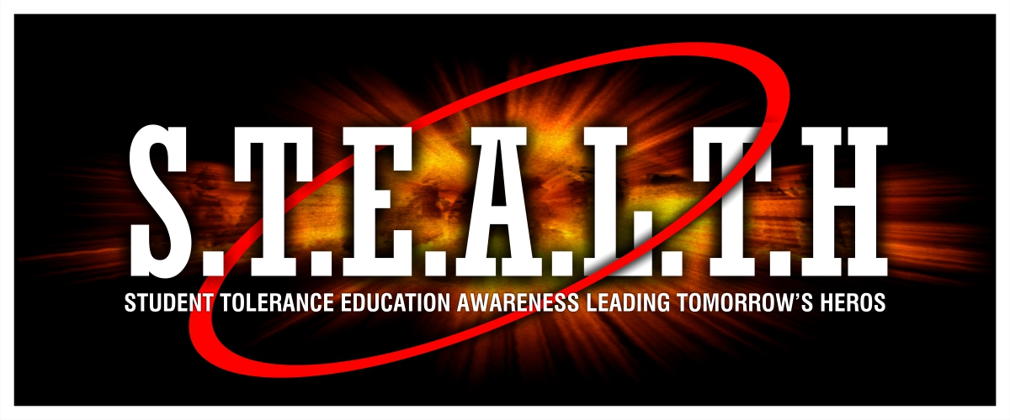

Elliot Lake  Sault Ste Marie  Blind River  Wawa
AYAA VALUES

- Health: A general state of wellbeing of the body and the mind. This reflects the AYAA because we support healthy communities by promoting healthy lifestyles.

- Social Justice: The idea that every individual and group is entitled to equal rights. This reflects the AYAA because we strive to voice our opinions around health promotion issues that challenge social justice for youth in our communities.

- Leadership: The ability to engage people in community based activities and events. This reflects the AYAA because we serve as mentors and role models supporting healthy lifestyles. We also inspire confidence and critical thinking skills to influence social change.

- Teamwork: The action by a group of people with a shared goal achieved by coordinated efforts. This reflects the AYAA because we make decisions based on our common goals and group consensus based on our different strengths.

- Diversity: A wide range of personalities, possibilities, and ideas. This reflects the AYAA because we all have different views, backgrounds, personalities and social circles. Everyone is welcome.

- Creativity: The process of developing new, unique ideas. This reflects the AYAA because we are always using creative ideas for activities or slogans or themes, etc.

- Respect: Courteous regard for people’s feelings and being considerate. The basis of our work is a deep respect for ourselves, each other, and others.

Algoma Youth Action Alliance

The Algoma Youth Action Alliance (AYAA) is a coalition across Algoma that consists of four youth-led health promotion committees.

- Wawa’s Teens In Motion
- Sault Ste. Marie’s Schools Without Borders
- Blind River’s STEALTH
- Elliot Lake’s Teens In Action

Each committee consists of students aged 12-24, Algoma Public Health staff, and supportive Community Partners. We get together once a month after school (snacks provided) to look at health issues important to us and come up with a plan to take action on them to help make our community stronger.

In working to reach this goal, youth reps can get to know other youth from different schools, across Algoma and even across the province. The committees also offer unique educational experiences. Some of the learning experiences for the student members have included:

- Supervised chairing of meetings.
- Reporting on events happening in their schools.
- Brainstorming ideas and planning projects and events.
- Organizing committee initiatives at their own schools.
- Working with the media including developing press releases, radio ads, doing television and newspaper interviews.
- Writing letters of request for Board of Education approval for activities planned by the committee and being the contact person to answer any questions about the activities.
- Opportunities to be sponsored to attend out-of-town youth conferences as a committee representative.
- Working on a sub-committee with students from other schools.
- Facilitating Power Point Presentations at a youth conference and Board of Education principal’s meetings on initiatives organized by the Schools Without Borders Committee.
- The unique opportunity to work with and learn from teachers and public health staff.

High school students can collect mandatory volunteer hours for their participation.

In addition to unique learning experiences, meeting new people, and doing things that
really make a difference in the community, committee work provides youth reps with
valuable experiences for future college/university applications, scholarship/award
applications, as well as resumes.

TERMS OF REFERENCE
Name: | Algoma Youth Action Alliance Coalition, which is comprised of four youth-led Committees in Wawa, Sault Ste Marie, Blind River and Elliot Lake.
Purpose/Goal: | To create youth development opportunities, in which members determine youth-led, health promotion priorities. Youth, in partnership with adult supports, promote healthy lifestyles through comprehensive initiatives across Algoma. Each committee focuses on their respective local community (i.e., Wawa, Sault Ste Marie, Blind River and Elliot Lake).
Objectives: | - Identify and share youth engagement and development opportunities for youth membership and peers.  - Keep Committee Members informed on current and emerging health related issues in the region and province.  - Work with community partners to ensure collaboration and information sharing.  - Mobilize youth to support youth-led health initiatives  - Deliver youth-led health promotion messages through planned initiatives to youth.
Chair: | Rotates among members.
Recorder: | Rotates among members.
Membership: | Each committee consists of Youth, supportive Teachers/Guidance Counsellors, and Community Partners from respective local communities in Wawa, Sault Ste Marie, Blind River, and Elliot Lake, supportive Algoma Public Health staff, and a Youth Engagement Coordinator.
Reporting to: | Tobacco Control Coordinator, Program Director for Chronic Disease, and Ministry of Health Promotion
Frequency: | Monthly meetings, with intermittent working groups as needed.
Term: | N/A
Decision-making Format: | Consensus is preferred, where possible.
Distribution of Minutes: | Committee Members, Program Director for Chronic Disease

Signature of Medical Officer of Health |  | Date

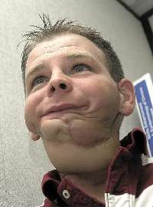
Gruen Von Behrens of Illinois toured local high school to talk about the dangers of chewing tobacco.
Photo: Michael Purvis

Shocking first impressions
Michael Purvis
Wednesday, December 06, 2006 - 00:00
Local News - A man whose life has been vastly changed by oral cancer is touring local high schools this week to warn students against tobacco.
Gruen Von Behrens started chewing tobacco when he was 13. By 17 he was diagnosed with oral cancer.
Now he's 29, and though he has been cancer-free for 12 years, during that time he has undergone more than 30 disfiguring surgeries to his face.
Students are often shocked by his appearance at first, but Behrens said they tend to "listen with their hearts."
While chewing tobacco is what changed his life, Behrens said he also stresses the dangers of smoking.
"Both types of tobacco can do this," said Behrens.
Today Behrens speaks at White Pines and Sir James Dunn. He will be at Central Algoma Secondary School on Thursday and Bawating and Korah on Friday.
A symposium will be held Thursday night for health-care providers and other health-based organizations. It will include a local panel made up of a young athlete, a coach and an oral surgeon, who will describe their experiences with chewing tobacco.
Behrens visited St. Basil secondary school and St. Mary's Collegiate on Monday. On Tuesday he travelled to Wawa to speak to students there.
He speaks to students all over the U.S., Canada and Mexico.
ID- 306819

© 2006 , Osprey Media. All Rights Reserved. This material may not be published, broadcast, rewritten, or redistributed.

Name: ____________________________________________________________________
Committee: ________________________________________________________________
Date Started: (MONTH/DAY/YEAR) _____________________________________________
Date Completed: (MONTH/DAY/YEAR) __________________________________________

Committee Involvement Tracker

Meetings Attended
Meeting Date | Volunteer Hours | Comments or Notes
TOTAL

Events/Activities
Activity | Date (D/M/Y) | #Vol Hrs | Role | What I Gained
TOTAL

Training Opportunities
Training | Date (D/M/Y) | #Vol Hrs | What I Gained | Comments
TOTAL

Request for reference/scholarship/postsecondary
___________________________________________________________________________________________________________________________________________________________________________________________________________________________________________________
_________________________________________________________________________________

Other Notes

___________________________________________________________________________________________________________________________________________________________________________________________________________________________________________________
If adapting, please include a reference line “adapted with permission from Algoma Public Health.”

