**Supporting Youth: Fostering Resiliency**

**Helping Teens Handle Tough Experiences: Strategies to Foster Resilience**

Jill R. Nelson, Ph.D., Sarah Kjos, M.Ed. *2008, 8.5 x 11, 128 pages* Paperback + CD-ROM

* + Life is hard for teens, but it can become even more difficult when they experience serious challenges. Removing the adversity from a teen's life may be out of our control, but we can help them deal with these experiences and build on their natural talents, goodness, and strength. This book highlights 20 tough experiences, and using research evidence and practical experience, the authors provide information and strategies that you can use to help guide a teen through troubled times. In addition to practical advice, suggestions, and tips for working with teens, each chapter also includes reproducible handouts, informational resources, and contact information for relevant organizations.

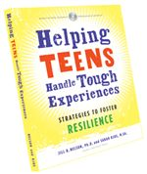

**Raise Them Up: The Real Deal on Reaching Unreachable Kids**

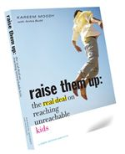

Kareem Moody *2006, 5.5 x 7.5, 112 pages* Paperback

* + Find out how society's many influences shape the lives of children at risk, and how they can thrive, even in the most difficult circumstances. The dramatic, real-world experiences of hard-to-reach youth inspire these vivid, compelling essays. Written by an ex-gang member, this book features a jargon-free approach that guides adults on effectively connecting with disengaged kids and turning seemingly dire situations into inspirational successes. Underlying each account is an emphasis on engaging at-risk young people in deliberate dialog about their unique strengths and the opportunities they have to grow up to be healthy, vibrant members of society—against all the odds. The book embodies Search Institute's Developmental Assets and includes five detailed, asset-building strategies for working with at-risk youth.

[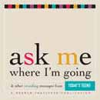](javascript:openWin('picturedetail.asp?pic=/snapupload/catalogue/SE854_lg.jpg','picturedetail','toolbar=0,location=0,status=0,top=10,left=10,menubar=0,scrollbars=yes,resizable=yes,width=300,height=380'))

**Ask Me where I'm Going: What Teens Want Adults to Know!**

*2004, 5.5 x 5.5, 80 pages,* Softcover

* + This intimate little book will touch your heart as you read poignant and practical “real words” from teens—describing what they really want from the caring adults in their lives. “Let me share my worries with you…Never give up on me…Encourage me more, criticize me less.” A perfect gift book for anyone who touches the lives of teens.

[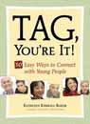](javascript:openWin('picturedetail.asp?pic=/snapupload/catalogue/SE830_lg.jpg','picturedetail','toolbar=0,location=0,status=0,top=10,left=10,menubar=0,scrollbars=yes,resizable=yes,width=300,height=380'))**Tag, You're It!: 50 Easy Ways to Connect with Young People**

Kathleen Kimball-Baker *2002, 5.5 x 7.5, 148 pages,* Softcover

* + Get inspired and motivated with this asset-building idea book! Offers 50 common-sense ways to connect and build assets with young people. Each inspirational idea contains a reference to a supportive research study or expert opinion and includes action items to help you journey toward positive change. Best Use: By parents, caregivers, teachers, childcare workers, and youth workers who want easy, practical ways to connect with young people.

**Mentoring for Meaningful Results: Asset Building Tips, Tools, and Activities for Youth and Adults**

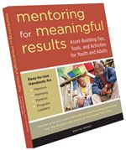

Kristie Probst *2006, 8.5 x 11, 120 pages* Paperback

* + Mentoring for Meaningful Results is a complete "start-up kit" that provides mentors, mentees, and parents or caregivers everything they need to establish and maintain a successful mentoring relationship. Using practical tips and activities along with the Developmental Assets framework, Mentoring for Meaningful Results will enhance both mentoring programs in schools, organizations, and communities across the country and the lives of the children and youth they serve.

**Supporting Youth: How to Care, Communicate, and Connect in Meaningful Ways**

Nancy Tellett-Royce *2008, 6 x 9, 128 pages* Paperback

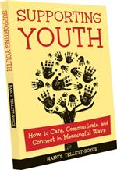

* + Find valuable tools for providing supportive leadership to youth. With an introduction to Search Institute's Developmental Assets framework and detailed descriptions of the six Support assets, both novices and seasoned professionals can incorporate relationship-building principles into their daily work. Your relationships with youth will benefit from easy-to-apply tips for building support at home, at work, at school, and in your community. Testimonies of youth and adults who are involved in successful support systems demonstrate these assets in action.

**Empowering Youth: How to Encourage Young Leaders to Do Great Things**

Kelly Curtis M.S. *2008, 6 x 9, 160 pages* Paperback

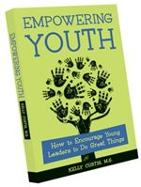

* + This guide demonstrates how youth leaders, teachers, peer program advisors, adults who work with teens and adolescents, and professional organizations with a youth focus can foster empowerment and leadership qualities in youth. Motivating examples combine with activities and reproducible self-assessment checklists to aid individuals and groups in evaluating their strengths and challenges in their efforts to empower youth. Tips can be used in one-on-one situations, groups, and structured programs. Ideas have been tested in varied circumstances, including youth programs, communities, classrooms, and faith-based organizations.